DEALS TO ANAHEIM

The city of Anaheim is so much more than Disneyland. Anaheim in the center of Orange County is a vibrant city in its own right. Book a trip to Anaheim via Los Angeles International Airport on Virgin America. Live it up at 35,000 feet with WiFi, on-demand entertainment, and more on every flight.

(MARKET IMAGE HERE)

Find Deals From These Cities

INSERT FARE GRID FROM / TO Version (if available!)

   
Top Things To Do in Anaheim

Wondering what to see in Anaheim? Although theme parks are one of the main attractions, there are many other great things to do in Anaheim for children and adults alike. You’ll want to make time for some of the must-do activities in this playful city.

* Spend the day at the Anaheim Packing District. This downtown area consists of many restored buildings and wonderful spots, including three must-sees: The Packard Building, Farmers Park, and The Packing House.
* Bring out your inner child and have fun playing miniature golf at what’s considered to be the largest miniature golf facility in the U.S. Aside from mini golf, Camelot Golfland also has water slides, a large arcade, laser tag and more.
* Venture out to the Oak Canyon Nature Center, a 58-acre scenic park in the Anaheim Hills. While exploring the four miles of hiking trails, you might discover some of the native wildlife that live in the canyon.
* Visiting Anaheim during baseball season? Head to Angel Stadium where you can see the Anaheim Angels in action on most nights. Ballpark Tours are available on certain dates and, when there isn’t a game, there are often concerts and other events taking place.

Travel Tips and Resources

[Must-Dos in Anaheim](http://www.tripadvisor.com/Attractions-g29092-Activities-Anaheim_California.html)

[Anaheim Hotels](http://www.tripadvisor.com/Hotels-g29092-Anaheim__California-Hotels.html)

[Anaheim Restaurants](http://losangeles.cbslocal.com/top-lists/best-restaurants-in-anaheim/)

[Anaheim Shopping Guidehttp://visitanaheim.org/explore/shopping](http://visitanaheim.org/explore/shopping)

[Anaheim Nightlife and Entertainmenthttp://visitanaheim.org/explore/nightlife](http://visitanaheim.org/explore/nightlife)

[Anaheim Travel Tipshttp://visitanaheim.org/plan/travel-tips-resources](http://visitanaheim.org/plan/travel-tips-resources)

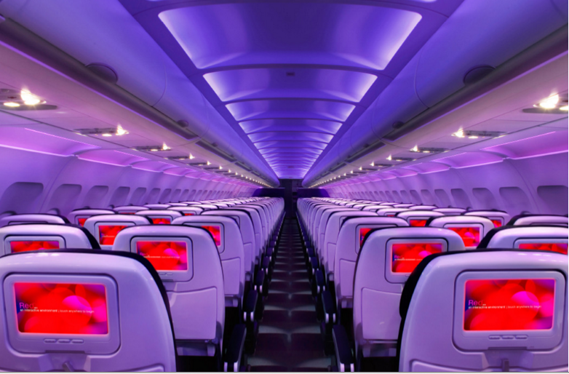

Main Cabin Main Cabin Select First Class

(add links to Cabin Class Pages)

Ready. Set. Fly.

Book your Mood-lit Ride to Anaheim.

Traveling to California and looking for flights to Anaheim? Book a flight to Los Angeles International with Virgin America and grab a delicious meal before setting off on the short drive to Anaheim. When you fly with us, you’ll be in great hands with our exceptional customer service and state-of-the-art amenities. Leather seats, on demand food ordering, and mood-lit cabins are just a few of the fabulous amenities that await you.

Take a Virtual Tour

Add Terms & Conditions